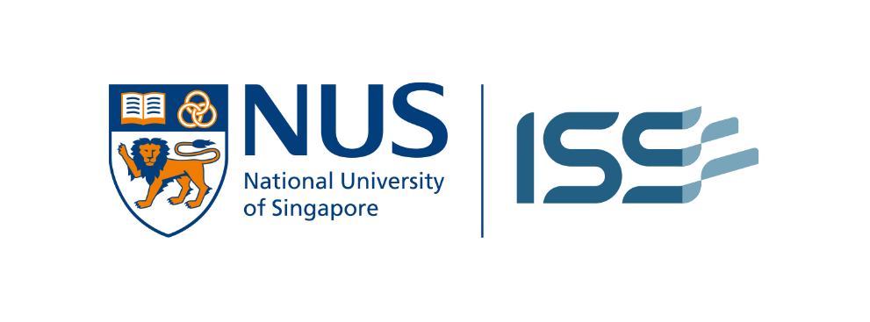

Project Proposal: S-Rank
An Intelligent Reasoning System for Fair and Traceable Skills-Based Candidate Ranking

Group Name:LaSSMart
Member Name 1 [ID]
Member Name 2 [ID]
Member Name 3 [ID]
Member Name 4 [ID]

Date of Submission: March 29, 2026

Contents
No table of contents entries found.
1. Introduction
1.1 Project Overview
S-Rank is a next-generation Intelligent Reasoning System (IRS) designed to transform the recruitment lifecycle from manual, keyword-heavy screening into a sophisticated, logic-based evaluation of human capital. Unlike traditional Applicant Tracking Systems (ATS) that rely on rigid string matching, S-Rank utilizes Symbolic Reasoning and Knowledge Graphs to interpret the semantic depth of a candidate’s experience. By mapping unstructured resume data against standardized skills frameworks, the system identifies the underlying competencies that make a candidate suitable for a role, even in the absence of exact terminology.
1.2 Project Relevance and Regulatory Context
The project is a direct response to two major shifts in the 2026 Singaporean labour market:
- Workplace Fairness Act (WFA) Compliance: As of 2026, the Workplace Fairness Act has transformed fair employment guidelines into enforceable law. Employers are now legally accountable for ensuring that hiring decisions are strictly merit-based and free from bias related to protected characteristics such as age, race, or nationality.
- Mandatory Transparency in AI: Under the WFA and IMDA’s AI Governance frameworks, firms using AI for screening must ensure their systems are not "black boxes". There is a critical requirement for traceability, meaning employers must be able to provide a clear, documented justification for why a candidate was or was not shortlisted.
1.3 National Strategic Alignment
S-Rank aligns with Singapore’s National AI Strategy 2.0 and the National AI Impact Programme (NAIIP) launched in March 2026.
- Identifying "AI-Bilingual" Talent: A core goal of the Singapore government is to upskill 100,000 workers to be "AI-Bilingual"—professionals who combine deep domain expertise (e.g., in Law, Accounting, or HR) with the ability to orchestrate AI systems. S-Rank is specifically engineered to detect this "powerful combination" of skills, which is often missed by conventional tools.
- Skills-First Hiring: The system supports the national shift away from academic pedigree toward demonstrated skills, helping to solve the talent scarcity gap that affects 72% of Singaporean employers.
1.4 Project Goals
- Develop a Robust Knowledge Base: To encode Singapore’s SkillsFuture frameworks into a machine-readable ontology for high-precision candidate matching.
- Ensure Legal Traceability: To implement an Inference Engine that generates a step-by-step Reasoning Trace for every ranking, serving as an audit log for WFA compliance.
- Eliminate Algorithmic Bias: To utilize Explainable AI (XAI) techniques that ensure candidates are ranked solely on job-relevant criteria, removing the risk of "unconscious bias" inherited from historical data.

2. Project Background / Market Context
2.1 The 2026 Talent Scarcity Paradox
In 2026, Singapore’s labor market is characterized by a "scarcity paradox." While overall talent shortages have moderated to 71% (down from 83% in 2025), the demand for specialized skills has intensified and shifted. For the first time, AI Model & Application Development (26%) and AI Literacy (25%) have emerged as the hardest-to-fill capabilities, displacing traditional IT and data roles. Employers are no longer engaged in broad headcount expansion but are instead focused on selective, skills-based recruitment to support structural transformation.
2.2 The Recruitment "Screening Bottleneck"
Recruiters in Singapore are currently facing intense operational pressure. Key market data indicates:
- Increased Application Volume: Job applications per posting have risen by 6%, yet 74% of recruiters report that finding truly qualified candidates has become more challenging.
- Intense Time Pressure: Four in 10 recruiters face pressure to fill roles significantly faster than in previous years.
- The "Black Box" Barrier: While 82% of Singaporean organizations are now using AI in their workforce strategies, only 4% feel that current AI tools fully meet their expectations for hiring and training.
2.3 Market Gap for Traceable Reasoning
Current market solutions often fall into the "automation trap"—they provide speed but lack the logical depth required for 2026 regulatory standards.
- Algorithmic Opacity: Existing tools often operate as "black boxes," providing ranking scores without explaining the underlying merit-based logic.
- Regulatory Risk: With Privacy and Regulatory concerns (16%) cited as the top barrier to broader AI deployment in 2026, firms are increasingly wary of automated tools that cannot be audited for bias.
- Need for Human-Centric AI: There is a critical demand for systems that do not replace human judgment but instead provide Explainable AI (XAI) outputs that human recruiters can verify and trust.
2.4 Economic Alignment: Budget 2026 and SkillsFuture
S-Rank is designed to operate within the specific economic framework established by Budget 2026, which emphasizes enterprise capability-building.
- Skills-First Labor Market: The Singapore government has doubled down on its commitment to a skills-first economy, moving hiring conversations away from prestigious degrees toward demonstrated capability and delivery.
- Supporting "Plug-Train-Play": Employers are increasingly adopting a "plug-train-play" approach, valuing practical experience and project portfolios over formal titles. S-Rank fills the market void for a tool that can "reason" through these non-traditional credentials to identify top-tier talent.
3. Literature Review / Market Research
3.1 Analysis of Current ML-Based Solutions (2026)
The 2026 recruitment market is dominated by "Sub-symbolic" AI platforms such as MokaHR, Eightfold AI, and SmartRecruiters. These systems utilize deep learning and natural language processing to achieve high-precision matching, often reducing time-to-hire by up to 63%.
- Functionality: These tools excel at pattern recognition and predictive analytics, identifying candidates based on historical data from billions of career profiles.
- Limitations: Despite their efficiency, these models are frequently "black boxes". They identify correlations in data (e.g., Candidate X "looks like" a successful hire) but cannot explain the causal logic behind the ranking. This lack of interpretability presents a significant legal risk under Singapore's Workplace Fairness Act (WFA).
3.2 Symbolic vs. Sub-symbolic Reasoning in Recruitment
Academic literature distinguishes between two primary AI mindsets: Machine Learning (ML) and Symbolic AI.
- Machine Learning (Sub-symbolic): Rely on statistical guessing and massive datasets to identify matches. While flexible, they are prone to algorithmic bias if trained on biased historical data (e.g., favoring specific genders or schools found in past "top performer" lists).
- Symbolic Reasoning (S-Rank Approach): Operates through explicit rules and formal logic. Every decision can be traced back to human-understandable computation flows, making the system a "transparent box". Symbolic systems excel in scenarios where data is scarce or where decisions must be defensible and audit-ready.
3.3 The Shift Toward Explainable AI (XAI)
By 2026, Explainable AI has moved from a research topic to a business infrastructure requirement.
- Traceable Outputs: The Ministry of Manpower (MOM) and TAFEP emphasize that AI tools must provide clear explanations for candidate rankings that employers can review and verify.
- Knowledge-Enhanced Matching: Recent research indicates that integrating Knowledge Graphs—as proposed for S-Rank—significantly improves semantic understanding in resume parsing. By explicitly modeling the relationship between skills and job requirements (e.g., Reasoning that "PyTorch" experience implies "Deep Learning" proficiency), S-Rank provides a more accurate and interpretable assessment than keyword-based tools.
3.4 Market Opportunity for S-Rank
While 81% of organizations have adopted some form of automated resume screening, there is a clear market gap for a Reasoning-First system.
- User Need: Recruiters in 2026 require tools that do not just provide a "score" but generate a Reasoning Trace.
- S-Rank Differentiation: S-Rank fills this void by using Rule-Based Reasoning to enforce meritocratic hiring, ensuring that every shortlisted candidate is selected based on a verifiable, logic-based "proof" of their capabilities.
4. Project Scope
4.1 Functional Scope
The S-Rank MVP will focus on the automated screening and merit-based ranking of candidates within two high-growth sectors in Singapore: Information Technology (IT) and Financial Services.
- Target Roles: The system will specifically target "AI-Bilingual" roles, such as AI-driven Accountancy, Legal Tech, and Cloud Solution Architecture.
- Skill Framework Integration: We will utilize the SkillsFuture Singapore (SSG) Skills Framework and the Institute of Banking and Finance (IBF) Standards as the core ontology for skill mapping.
- Output: The primary output will be a ranked list of candidates accompanied by a Reasoning Trace—a natural language explanation of why each candidate was selected based on job-related criteria.
4.2 Intelligent Reasoning Focus
To move beyond keyword matching, S-Rank will implement two primary reasoning paradigms:
- Forward Chaining (Data-Driven Reasoning): This inference technique will be used to deduce a candidate’s suitability from their resume data. By applying IF-THEN rules (e.g., IF a candidate has "Terraform" AND "AWS" skills, THEN they possess "Cloud Infrastructure" competency), the system builds a logic-based profile of the applicant.
- Constraint Satisfaction: We will use this technique to enforce the Workplace Fairness Act (WFA) requirements. The system will treat legal mandates—such as the prohibition of discrimination based on age or race—as "Hard Constraints" that must be satisfied before any final ranking is produced.
4.3 Cognitive Systems (CGS) Integration
- Explainability (XAI): In alignment with National AI Strategy 2.0, S-Rank will function as a "Cognitive Assistant" for recruiters. It will not replace the final human decision but will provide an interpretable "Mental Model" of its ranking logic, allowing recruiters to audit and verify the AI's suggestions.
- Natural Language Understanding (NLU): The system will focus on extracting "Generic Skills" and "Critical Core Skills" (e.g., Problem Solving, Adaptability) from unstructured text to identify high-potential mid-career switchers.
4.4 Limitations and Constraints
- Data Privacy: To comply with the Personal Data Protection Act (PDPA) and WFA guidelines, all resume data used in the MVP will be anonymized to remove non-job-related personal identifiers.
- Geographic Scope: The system is specifically calibrated for the Singaporean regulatory environment and may not be applicable to jurisdictions with different labor laws.
5. Data Collection and Preparation
5.1 Data Acquisition Strategy
Our group will adopt a dual-stream data collection strategy to build a comprehensive repository for the IT and Financial Services sectors:
- Job Description (JD) Corpus: We will scrape job postings from MyCareersFuture.gov.sg to capture the latest industry-standard "AI-Bilingual" requirements in Singapore.
- Resume Dataset: We will utilize anonymized, open-source resume datasets (e.g., from Kaggle or HuggingFace) to provide a diverse range of candidate profiles for initial testing.
- Knowledge Sources: Domain knowledge will be codified from the SkillsFuture Singapore (SSG) Skills Framework and the Institute of Banking and Finance (IBF) Standards.
5.2 Knowledge Engineering & Fact Extraction
To convert unstructured PDF/Word documents into a structured Fact Base, we will implement a multi-stage Natural Language Processing (NLP) pipeline:
- Parsing & Normalization: Using OCR fallbacks (e.g., Tesseract) and segmenters (e.g., YOLOv8) to ensure high-quality text extraction from various resume layouts.
- Entity Extraction: Identifying and extracting key entities such as Skills, Certifications, Years of Experience, and Job Titles.
- Fact Representation: Transforming extracted entities into a machine-readable format (e.g., JSON or RDF). For example, a candidate’s experience with "PyTorch" will be represented as a formal fact: has_skill(Candidate_X, PyTorch).
5.3 Building the Skills Ontology
To enable Machine Reasoning, S-Rank will go beyond simple lists and create a Knowledge Graph of skills:
- Semantic Mapping: Mapping diverse job titles and skill variations to a consistent taxonomy (e.g., "Software Engineer" and "App Developer" mapped to a common "IT Professional" node).
- Relationship Modeling: Encoding hierarchical relationships (e.g., Reasoning that "PyTorch" is a child node of "Deep Learning") to identify candidates with related or adjacent competencies.
5.4 Data Quality and Privacy (PDPA Compliance)
- De-identification: In strict compliance with the Personal Data Protection Act (PDPA) 2026, all resumes will undergo an anonymization process to remove unique identifiers such as NRIC numbers, full names, and contact details.
- Validation Rules: Implementing strict Pydantic schema validation to catch data gaps, overlapping date ranges, or inconsistent career trajectories before the data enters the inference engine.
- Integrity Audits: Regular data quality checks will be performed to ensure the Fact Base remains accurate and unbiased, a key requirement for Workplace Fairness Act (WFA) compliance.
6. System Design
6.1 High-Level Architecture
The S-Rank system architecture is designed as a modular, Knowledge-Based Intelligent Reasoning System, structured into three core sequential blocks: Data Acquisition (Extraction), The inference Engine (Reasoning), and the Explanation Module (Output). The flowchart follows the processing lifecycle of a candidate resume:
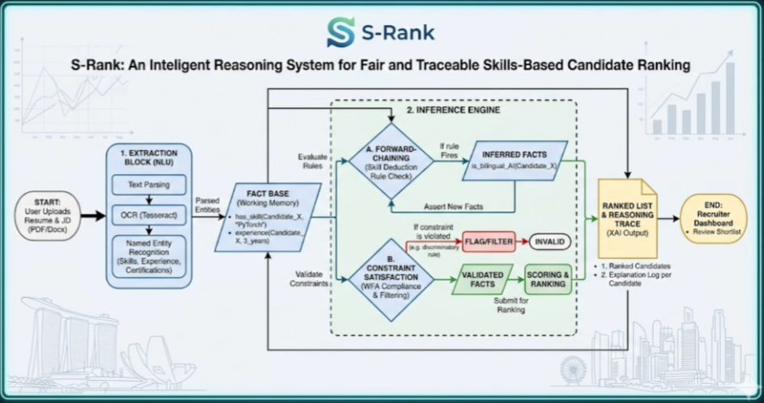
The S-Rank architecture is a hybrid intelligent system that integrates a Knowledge Base, a multi-stage Inference Engine, and an Explainability Module.
- Knowledge Base (KB): Encodes the SkillsFuture Singapore (SSG) frameworks and Workplace Fairness Act (WFA) mandates into formal logic (Facts and Rules).
- Inference Engine: The "brain" of the system, which processes candidate data against the KB to derive suitability scores.
- Explainability Module: Acts as the cognitive bridge, translating internal logical proofs into natural language "Reasoning Traces" for human recruiters.
Process Flow: From Unstructured Data to Traceable Ranking
Stage | Process Description | IRS Relevance
Input | The process begins when a recruiter uploads a job description (JD) and a set of candidate resumes (PDF/Docx) via the User Interface. | Input Data Stream
I. Extraction Block (NLU) | This block acts as the system's "sensory input," translating unstructured text into structured information. An NLP pipeline, potentially using Named Entity Recognition (NER) and OCR pre-processing, extracts critical facts such as identified Skills, Certifications, Years of Experience, and Academic history. | Entity & Fact Extraction
II. The Inference Engine | The core "thinking" module of S-Rank. It ingests extracted facts into its Working Memory and begins applying logical rules from the Knowledge Base (SSG Ontology & WFA Logic):  • Forward Chaining (Skill Deduction): Deduces hidden capabilities (e.g., inferring is_bilingual_AI(User_A) from the presence of skill(User_A, "Python") and skill(User_A, "Finance Domain")).  • Constraint Satisfaction (WFA Compliance): Treats merit-based hiring criteria as "Hard Constraints" to filter out non-compliant data.  • Scoring & Ranking: Assigns a weight-based merit score to each candidate based on their logical alignment with the JD. | Knowledge Engineering & Symbolic Reasoning
III. Explanation Module (XAI) | The finalized ranked list is passed to the output module, which translates the system’s internal logical proofs (the trace of fired rules) into a human-understandable Reasoning Trace. The final output for the recruiter dashboard is not just a numeric rank, but a justifiable audit log for every candidate. | Explainable AI (XAI) & Cognitive Assistant

6.2 The Inference Engine: Dual-Logic Strategy
To achieve "Fair and Traceable" ranking, the engine utilizes two distinct reasoning methodologies:
- Forward-Chaining (Skill Deduction):
  - Starting with raw resume facts (e.g., "Candidate knows PyTorch"), the engine applies Modus Ponens to infer higher-level competencies (e.g., "Candidate is proficient in Deep Learning").
  - This data-driven approach allows the system to discover "AI-Bilingual" potential by deducing adjacent skills that keyword-based systems might miss.
- Constraint Satisfaction (Compliance & Filtering):
  - The engine treats WFA requirements and mandatory job credentials as "hard constraints".
  - Any candidate profile that violates a constraint (e.g., missing a required professional license) is automatically flagged or filtered, ensuring that the final shortlist is legally and professionally compliant.
Technical Highlight: Sample Reasoning Rules
To move beyond simple keyword matching, S-Rank utilizes a set of formal IF-THEN logical statements within its Knowledge Base. These rules allow the system to perform Forward Chaining, deducing high-level competencies from basic resume facts.

Rule 1: AI-Bilingual Deduction (IT & Finance)
This rule identifies candidates who possess the "powerful combination" of domain expertise and AI fluency required by National AI Strategy 2.0.

IF candidate_has_skill("Financial_Analysis")

AND candidate_has_skill("Python")

AND candidate_has_certification("AWS_Certified_AI_Practitioner")

THEN assert_fact("Is_AI_Bilingual_FinTech")

AND assign_merit_score(+25)

AND log_reason("Candidate demonstrates cross-domain fluency in Finance and AI.")

Rule 2: WFA Merit-Based Constraint
This rule ensures the ranking remains strictly merit-based and compliant with the Workplace Fairness Act (WFA) by ignoring non-job-related attributes.

IF job_requirement("Chartered_Accountant_Singapore")

AND NOT(candidate_has_credential("ISCA_Member"))

THEN flag_constraint_violation("Missing Mandatory Professional Qualification")

AND set_candidate_status("Ineligible")

AND exclude_from_ranking()

Rule 3: Transferable Skills Reasoning
This rule allows the system to recognize "hidden talent" by mapping adjacent skills within the SkillsFuture framework.

IF candidate_has_skill("Tableau")

OR candidate_has_skill("PowerBI")

THEN infer_skill("Data_Visualization_Competency")

AND match_requirement("Business_Intelligence_Reporting")
6.3 Explanation Module & Reasoning Trace
A critical component of S-Rank is its ability to transition from a "black-box" to a "glass-box" framework.
- Traceability: For every candidate ranked, the system logs the chain of rules fired during the inference process.
- Justification: Instead of a simple numeric score, the system provides a specific rationale (e.g., "Candidate ranked #2 due to strong 85% alignment with 'Cloud Architecture' and verified 'Terraform' certification, satisfying the Core Technical Constraint").
- Human-AI Collaboration: This module allows recruiters to calibrate weights for specific skills (e.g., weighing "Practical Experience" higher than "Certifications") and see the real-time impact on the ranking.
6.4 Implementation Stack
- Core Reasoning: Python-based expert system frameworks (e.g., Experta or CLIPS integration) for rule-based logic.
- Knowledge Representation: Knowledge Graphs (e.g., Neo4j) to model the complex relationships between Singaporean industry sectors and required competencies.
- Data Validation: Strict schema enforcement (e.g., Pydantic) to ensure the integrity of the "Fact Base" before reasoning begins.

